Winery locations/directions
Dry Comal Creek Vineyards- 1741 Herbelin Rd, New Braunfels, TX 78132
Located just outside New Braunfels in the Texas Hill Country, a few miles northwest of the city near Highway 46. The vineyard is roughly between New Braunfels and Canyon Lake, making it an easy stop when traveling through the southern Hill Country.
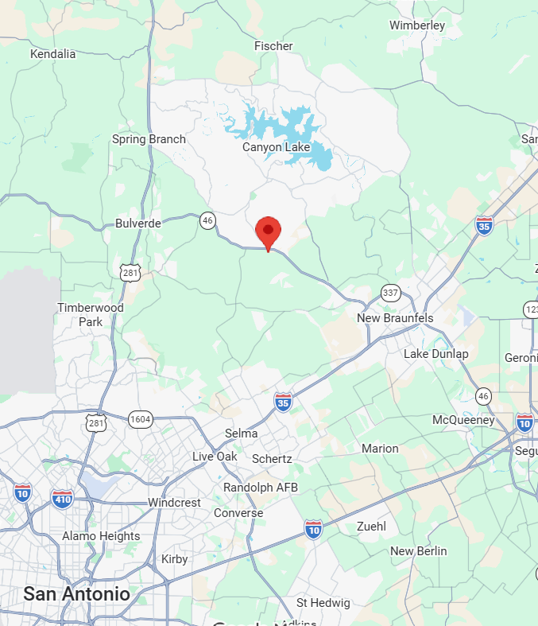

Jaclynn Renee Wines-107 Henson Rd, Wimberley, TX 78676
Located in the heart of Wimberley, southwest of Austin in the central Texas Hill Country. The tasting room is conveniently situated near Wimberley’s downtown shops, restaurants, and other local attractions.
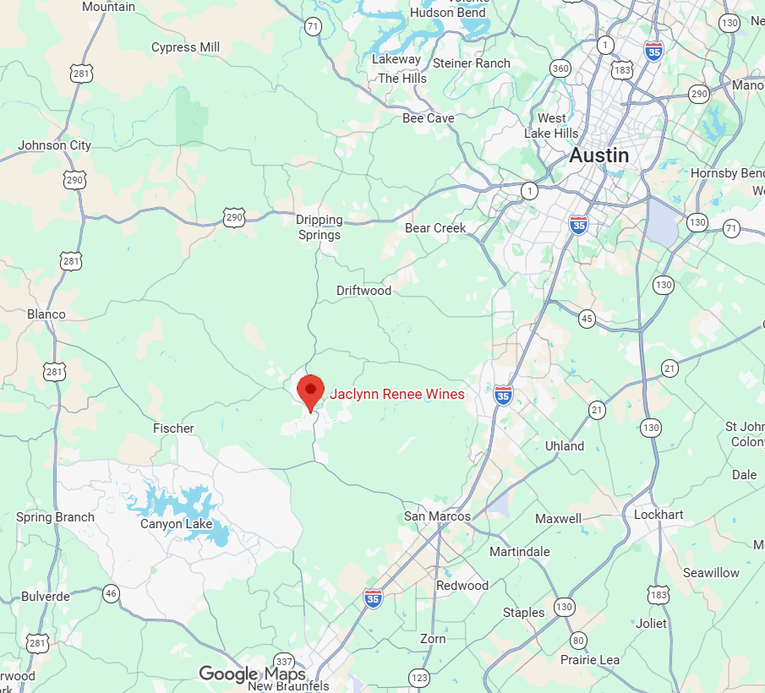

Saint Tryphon Farm & Vineyard-24 Wasp Creek Rd, Boerne, TX 78006
Located in the Hill Country outside Boerne, northwest of San Antonio near the Sisterdale area. The winery is approximately 30 minutes from San Antonio and provides a rural stop along the Hill Country wine route.
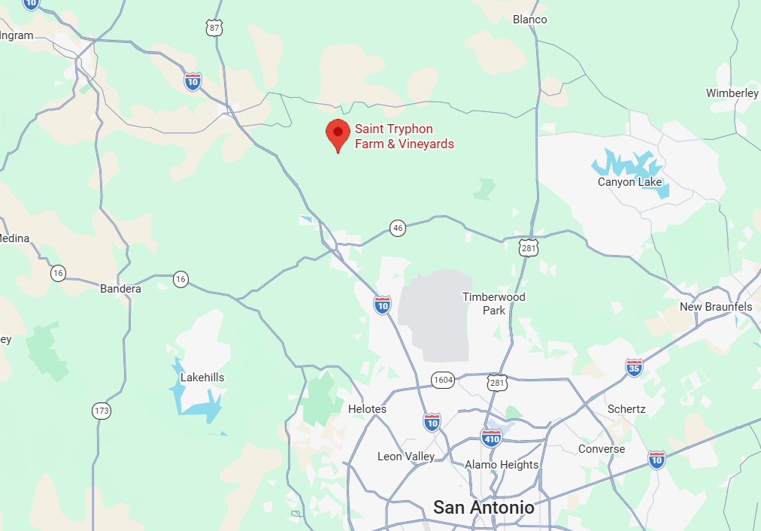

The Austin Winery-440 E St Elmo Rd, A1, Austin, TX 78745
Located in South Austin’s St. Elmo district, about 10–15 minutes south of downtown Austin. Unlike many Hill Country wineries, it offers an urban winery experience within Austin itself.
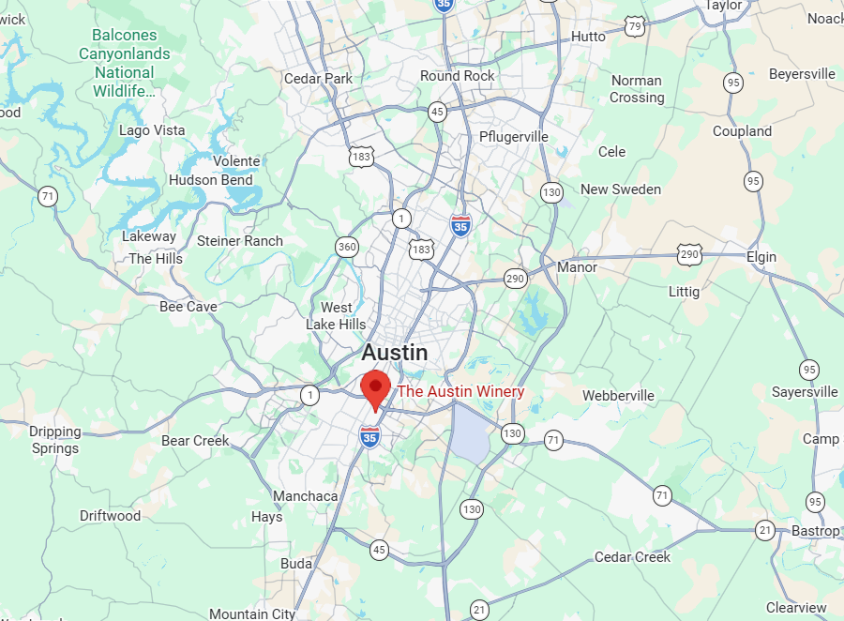

Wildseed Farms-100 Legacy Dr, Fredericksburg, TX 78624
Located just outside Fredericksburg in the heart of Texas wine country, east of town along the Highway 290 corridor. Its location makes it a convenient stop while exploring Fredericksburg and the surrounding Hill Country wineries.
